Single Interface Testing

Deadline : Wednesday 26 may 2021

PROJECT TITLE: **THEHIJABDOTCOM (https://thehijabdotcom.store)**

# GROUP MEMBERS:

**Ubab Nadeem | 18b-130-se**

**Talha Ahmed | 18b-024-se**

**Hammad Khan | 18b-110-se**

**Areesha Binte Najmi | 18b-020-se**

**Note make separate file for each single interface and transactional interface**

**Then Save it in \\Dropbox\0-Sp21 SVV\Black box testing\Sec # \Project title\<name of interface>**

# For single interface, those interface that are based on single table ( e.g. Participant , item, specific Item), in add mode, at least 5 different controls

# Step 1 : Paste the image of interface

**IMAGE OF COPLETE INTERFACE:**

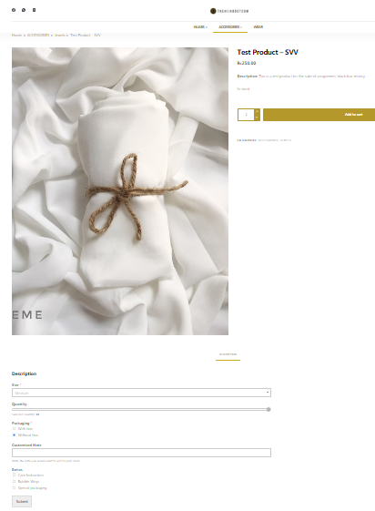

**CLEARER PICTURE OF EACH CHUNK OF INTERFACE:** 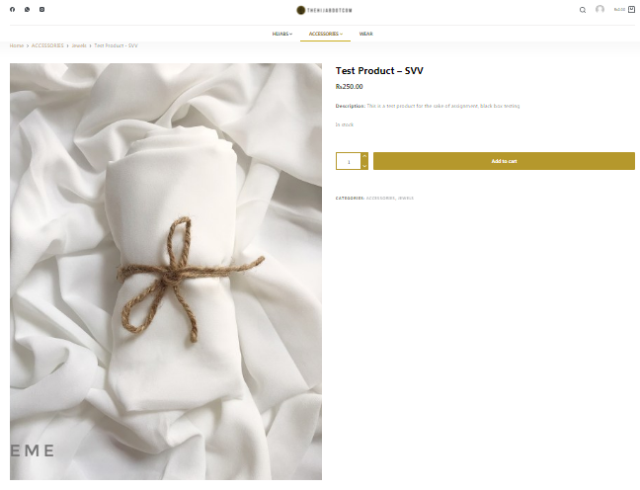

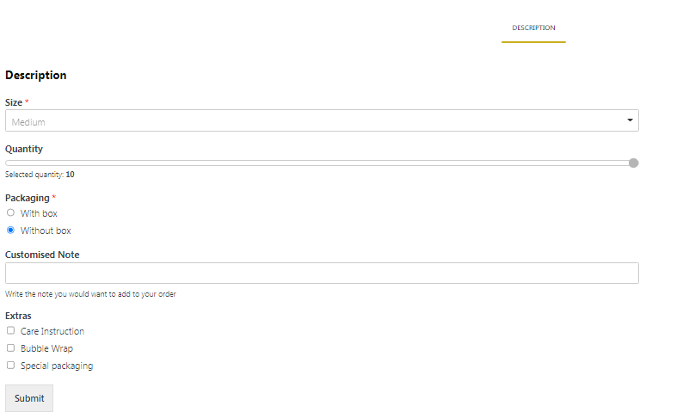

# Step 2: Show their datatype and 4 valid values

|  |  |  |  |  |  |  |  |
| --- | --- | --- | --- | --- | --- | --- | --- |
| Controls | Control type | Datatype | Valid value 1 | Valid value 2 | Valid value 3 | Valid value 4 | I used test case of (file name) |
| Size | Dropdown list | String (str) | Small | Medium | Large | - | 17B-034-SE Muhammad Aamir Dropdown List Box.docx |
| Quantity | Number Slider | Number | 1 | 3 | 5 | 2 | Aadil akber ali (17b-056-se)SLIDDER & SPINNER.docx |
| Packaging | Radio Button | Char(1) | With box | Without box | - | - | 17B-040-SE Muhammad Immaduddin Radio Button.docx |
| Customised Note | Text Box | Alphanumeric | Happy Birthday dearest friend laiba, have a good one, enjoy your day. I hope you adore this small token of love from my side | Keep up the spirit and stay the same incredible women that you are.  With Love, Your elder brother | Happy Birthday Ammi Jaan 😊 | May you have an amazing day. I hope you love what I sent you today!  -Your bestfriend | 17B-010-SE MADIHA SHUJAAT TEXTBOXES ALPHANUMERIC, docx |
| Extras | Check Box | Boolean | Bubble Wrap | Care Instruction | Special Packaging | - | 17B-031-SE Komal Tahir CheckBox.docx |

FOR EACH CONTROL:

**DROPDOWN LIST:**

**TEST CASES**

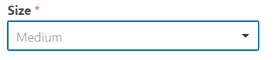

* **We have dropdown list option in which we can select any option in list by clicking it.**

|  |  |  |  |
| --- | --- | --- | --- |
| **TEST CASE** | **INPUT** | **OUTPUT** | **STATUS** |
| Choose option by clicking | Click on size Medium | Medium size selected | Valid |

* **Deselect the selected option and select another.**

|  |  |  |  |
| --- | --- | --- | --- |
| **TEST CASE** | **INPUT** | **OUTPUT** | **STATUS** |
| Deselect the selected option and choose another | Again click on size Medium to deselect it and then click on Small | Medium size deselect and Small size selected in replacement of Medium. | Valid |

* **Presentation of data:**

|  |  |  |  |
| --- | --- | --- | --- |
| **TEST CASE** | **INPUT** | **OUTPUT** | **STATUS** |
| Display data | Open options list | It will show options available to choose. | Valid |

**GUIDELINES:**

* Do check for appropriate sign displayed (as arrow) over control.
* Do check for default value that should be displayed or it should be BLANK.
* Do check if list contains number of values then “Scroll” option should display and it should be working.
* Do check for alignment of list is associated with control.
* Do check for “TEXT” identifier displayed with the control.
* Do check after clicking on arrow image should display as clicked.
* Does all the dropdowns on this screen sorted correctly? Alphabetic sorting is the default unless otherwise specified.
* Do ensure that the names are not abbreviations / cut short.
* Does the design of the drop-down i.e. its alignment with other items on the page on all common browsers?
* Does that the drop-down accommodates the longest text within its boundary.
* Does that the drop-down can be scrolled down on clicking the down arrow.
* Does that the drop-down has a proper title.
* Does that the default item is getting displayed when the user first visits the page.
* Does that on clicking the down arrow all items are getting listed in its expected order.
* Does the spelling, font and style of the text inside the drop-down.
* Does that on clicking the size, the page displays the corresponding sizes.
* Does that the selected category is getting highlighted on selecting the item.
* Does the time taking in loading the sizes under each size category? Too much time should not be taken for loading the sizes.
* Does the correctness of the sizes in this drop-down is ensured? If the list (of sizes) of this drop-down is controlled by some other selection (say in another drop-down or check-box, radio-button)
* If the selection in this drop-down is controlling some other control (say, enabling/disabling etc) then check the proper action.
* Does the user is able to select the sizes by pressing the down key on the keyboard.

**REFFERENCES:**

1. <https://hostadvice.com/how-to/how-to-install-and-configure-wp-super-cache-plugin-on-wordpress/>
2. <https://www.softwaretestinghelp.com/>
3. <https://www.pcmag.com/picks/the-best-mobile-device-management-mdm-solutions>

**NUMBER SLIDER:**

**TEST CASES**



* **What does slider has its default value?**

|  |  |  |  |
| --- | --- | --- | --- |
| **TEST CASE** | **INPUT** | **OUTPUT** | **STATUS** |
| Slider default value | Default value of number slider? | It will show slider with 0 level means default value will be 1. | Valid |

* **What does minimum and maximum value of slider?**

|  |  |  |  |
| --- | --- | --- | --- |
| **TEST CASE** | **INPUT** | **OUTPUT** | **STATUS** |
| Minimum value | Minimum value of number slider? | Output will be 1 | Valid |
| Maximum value | Maximum value of number slider? | Output will be 10 according to our case. | Valid |

* **What does the slider’s value has impact on different functionalities of application?**

|  |  |  |  |
| --- | --- | --- | --- |
| **TEST CASE** | **INPUT** | **OUTPUT** | **STATUS** |
| Functionalities | Adjust value at 3 | It will give value 3 | Valid |
|  | For knowing about quantity more or less. | It will show high bar at value if more quantity and less value for less quantity. | Valid |

* **What the slider do/ is status does slider have after restarting application OR what dose its default value?**

|  |  |  |  |
| --- | --- | --- | --- |
| **TEST CASE** | **INPUT** | **OUTPUT** | **STATUS** |
| After restarting default value of Slider? | After restarting application default value of number slider? | It becomes according to selected quantity such as 3. | Invalid |
|  | After restarting application default value of number slider? | It becomes 1 as default value. | Valid |

**GUIDELINES:**

* (Verify that any function selected in the) Does the functions in this Application should starts within 5 seconds?
* (Verify that the)Does the slider is placed in a position where it is easily visible?

**REFFERENCES:**

## [1] Whitwam,R.(2018,sep 26), [There's no way to silently change the ringer volume in Android Pie, but a fix is coming](https://www.androidpolice.com/2018/09/26/theres-no-way-silently-change-ringer-volume-android-pie-fix-coming/), Android police, <https://www.androidpolice.com/2018/09/26/theres-no-way-silently-change-ringer-volume-android-pie-fix-coming/>

**RADIO BUTTON:**

**TEST CASES**



* **Does user select multiple radio buttons?**

|  |  |  |  |
| --- | --- | --- | --- |
| **TEST CASE** | **INPUT** | **OUTPUT** | **STATUS** |
| Multiple radio buttons | Click with box radio button. | It selects with box option. | Valid |
|  | Click on without box radio button. | It selects without box option. | Valid |
|  | Click on both options at a same time. | It keeps unselecting the previous option when we try to select a new one | Invalid |

* **Does user submit order without selecting any radio button?**

|  |  |  |  |
| --- | --- | --- | --- |
| **TEST CASE** | **INPUT** | **OUTPUT** | **STATUS** |
| Submitting order | Click with box option | Order will submit | Valid |
|  | We don’t select any packaging option. | Order will not accepted, we must fill the required fields and packaging is a required field which is denoted by a staric. | Invalid |

* **Option selection or deselection:**

|  |  |  |  |
| --- | --- | --- | --- |
| **TEST CASE** | **INPUT** | **OUTPUT** | **STATUS** |
| Selection | Click on without box option. | It will select this radio button. | Valid |
| Deselection | If above selection wrong so click on with box radio button. | So it will select with box radio button in replacement of without box radio button. | Valid |
|  | If we again click on without box radio button to deselect it. | It will not shift to with box radio button. | Invalid |

**GUIDELINES:**

* Does radio button have a default value?
* Does radio button spell correctly?
* Does the radio button list all the required options?
* Does the radio button visible on the screen or web page?
* Does the alignment and color of the radio button is same?
* Does radio button show the correct options again each ratio buttons?
* Does radio button control could be checked or unchecked through Tab key or with the help of mouse cursor
* Does the radio button allow for single selection?
* Does the radio button are labeled correctly?
* Does the radio buttons have proper alignment with the controls in window?

**REFFERENCES:**

* <https://www.stickyminds.com/sites/default/files/article/file/2014/Graphical%20UI%20Testing%20Checklist.pdf>

**TEXTBOX:**

**TEST CASES**

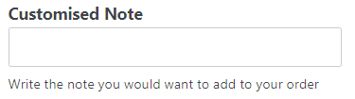

* **Does that Use blank and non-blank data?**

|  |  |  |  |
| --- | --- | --- | --- |
| **TEST CASE** | **INPUT** | **OUTPUT** | **STATUS** |
| Blank and Non-Blank | Aresha Najmi | Accepted | Valid |
| Blamk and Non-Blank |  | Accepted (since customized note is not a required field | Valid |

* **Does that include valid characters & symbols?**

|  |  |  |  |
| --- | --- | --- | --- |
| **TEST CASE** | **INPUT** | **OUTPUT** | **STATUS** |
| Charachers or Symbols | **@**arshi | Accepted | Valid |
|  | arshi@123 | Accepted | Valid |
|  | Aresha-Najmi | Accepted | Valid |

* **Does that Include data items with first position blank?**

|  |  |  |  |
| --- | --- | --- | --- |
| **TEST CASE** | **INPUT** | **OUTPUT** | **STATUS** |
| Data item | _esha | Accepted | Valid |

* **Does that Include data items with last position blank?**

|  |  |  |  |
| --- | --- | --- | --- |
| **TEST CASE** | **INPUT** | **OUTPUT** | **STATUS** |
| Data item | Aresh_ | Accepted | Valid |

* **Does that Include data with alphabets and numbers.**

|  |  |  |  |
| --- | --- | --- | --- |
| **TEST CASE** | **INPUT** | **OUTPUT** | **STATUS** |
| Alphabets | Aresha | Accepted | Valid |
| Only numbers | 1332647890 | Accepted | Valid |
| Alphabets with numbers | Aresha456 | Accepted | Valid |

**GUIDELINES:**

* Do the Textboxes for blank data should be in parted form.
* Does the Enter invalid value is not mandatory textbox.
* Does the Enter valid value in mandatory Textbox and save the window. Again come to same window and delete the value and test if it asks for value as it is mandatory.
* Does the Disabled Textbox should be grayed out.
* Does the Check for Blinking cursor when get focused.
* Does the Check for Formatted Textbox which should have proper format for predefined and accepting the same characters in the same format for.
* Do the Text box validation will leads you to your account.

**REFFERENCES:**

Tzemach, David. “Checklist for Testing Text Input Fields: David Tzemach.” *Checklist for Testing Text Input Fields | David Tzemach*, 1 Jan. 1970, [www.machtested.com/2016/06/checklist-for-testing-text-input-fields.html](http://www.machtested.com/2016/06/checklist-for-testing-text-input-fields.html).

**CHECKBOX:**

**TEST CASES**

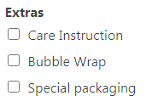

* **Check if the checkbox is selectable or not.**

|  |  |  |  |
| --- | --- | --- | --- |
| **TEST CASE** | **INPUT** | **OUTPUT** | **STATUS** |
| Check textbox | Click on any text box to check it is checkable or not. | Checkable | Valid |

* **Check if the checkbox selection enables the specific element as selected by mouse pointer or keyboard selection.**

|  |  |  |  |
| --- | --- | --- | --- |
| **TEST CASE** | **INPUT** | **OUTPUT** | **STATUS** |
| Check options | Click via mouse or keyboard selection. | Clickable with both. | Valid |

* **Check if the multiple checkboxes can be selected or not.**

|  |  |  |  |
| --- | --- | --- | --- |
| **TEST CASE** | **INPUT** | **OUTPUT** | **STATUS** |
| Multiple check boxes | Select more than one check box at a time. | Acceptable | Valid |

* **Uncheck one checkbox and select another and click on submit and verify if different choice is considered in redirection.**

|  |  |  |  |
| --- | --- | --- | --- |
| **TEST CASE** | **INPUT** | **OUTPUT** | **STATUS** |
| Multiple options | Select more than one options at a time then click on submit. | Order submitted. | Valid |
|  | If any option wrong then again click on that button it will disable and click on another of your choice. | Order submitted | Valid |

**GUIDELINES:**

* Do verify if the selection control is inactive when the page is loaded.
* Do verify if the initial focus of the checkbox is on the first checkbox.
* Do verify if the checkboxes are placed in an order.
* Do verify the physical location of the checkboxes.
* Do verify appropriate events associated with checkbox property change.
* Does alignment is proper with other controls in window?

**REFFERENCES:**

1. <https://hostadvice.com/how-to/how-to-install-and-configure-wp-super-cache-plugin-on-wordpress/>
2. <https://www.softwaretestinghelp.com/>
3. <https://www.pcmag.com/picks/the-best-mobile-device-management-mdm-solutions>

INTERFACE TESTING

|  |  |
| --- | --- |
| **Testcases** | **I use testcases of (filename)** |
| Aesthetic Conditions | 17B-063-SE Usaid Alam Aesthetic Conditions |
| Validation Conditions | AsmaKhan_17B-052-SE_Validation Conditions |
| Navigation Conditions | 17B-040-SE(A)-Muhammad Immaduddin Navigation |
| Data Manipulation Operation Conditions | 17B-034-SE Muhammad Aamir Data Manipulation Operations |
| Usability Conditions | 17B-002-SE Faraz Yar Khan - Usability Conditions |
| Feedback | 17B-022-SE Ibad hashmi Feedback |
| Data Integrity Conditions | 17B-028-SE Aliza Siddiqui Data Integrity Conditions |
| Modes (Editable Read-Only) Conditions | 16B-001-SE - Mansoor Masood - Modes (Read-only, Editable) |
| General Conditions | 17B-049-SE Hassan Ahmed Siddiqui General Conditions |
| Context | Not Available |
| External Interface | Not Available |
| Internal Interface | 17B-010-SE Madiha Shujaat |
| Connection Speed | 17B-030-SE Hassan Moin |
| Browser Setting and Compatibility | 17B-026-SE M Umair Zafar |
| E-Commerce | Not Available |
| Cookies | 17B-044-SE Riffat Siddique |
| Security | 17B-047-SE Saba Hayat Khan |

# Aesthetic Conditions:

**Purpose:**

The tester while testing for aesthetic conditions could use this checklist to check for mobile UI because, the purpose of aesthetic condition is use to validate screen, where we check the alignments, fonts, sizes, and colors along with the look of any controls with its respective background.

**Testcases:**

* Input Based (not found):
* Step Based:

1. Does it show responsiveness after zooming in and zoom out?

ZOOMED OUT:

ZOOMED IN:

1. Does the screen orients in both portrait and landscape mode?

PORTRAIT

LANDSCAPE:

**Guidelines:**

* Does the color of background correct?
* Does the application fits in all resolution?

# Validation Conditions:

**Purpose:**

Validation is an auto checked by the computer to make sure that the data entered by the user is correct. The purpose of it is to assess the transaction that is being implemented. Entered data is validated to ensure that the product fulfills the requirements that are demanded by the user.

**Testcases:**

* Input Based (not found):

1. Do you support copy & paste into the field?

No. it does not support copy and paste.

1. Do you allow typos or abbreviations?

It underlines the typo mistakes.

1. Do you enable different border styles?

No.

* Step Based:

1. Do the field is big enough so that most possible field values are visible?

**Guidelines:**

* Do the label above it? (Not inside, not below)
* Do this is field necessary?
* Do the field have all the required options?
* Do the field marked as required (*) or optional?
* Does the field have enough information?

# Navigation Conditions:

**Purpose:**

The purpose of data Navigation is to travel or in webpage context its moving from one page to another or in the radio button context it will be transferring from on page of app to another or it can be used as data input operator. Effective data navigations procedures usually are handled not completely independently from the procedures of initial data collection.

**Testcases:**

* Input Based (not found):
* Step Based:

1. Does the screen be accessed correctly from the menu?

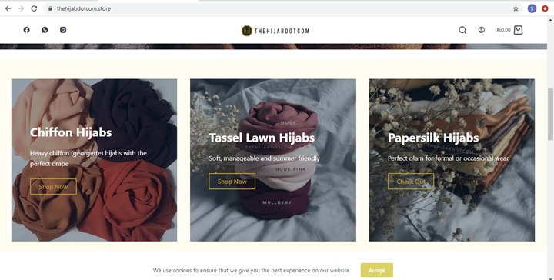

1. Does your navigation bar have proper responsiveness?



1. Does the application successfully start and exits?



**Guidelines:**

* Does your navigation bar consist of your application name?
* Does your navigation bar have proper readable content?
* Does your navigation bar consist of proper color scheme and is it visible?

# Data Manipulation Operation Conditions:

**Purpose:**

The purpose of manipulation operations is inserting data into database tables, retrieving existing data, deleting data from existing tables and modifying existing data.

**Testcases:**

* Input Based:

1. After the update do the data is still safe.

Answer:

**yes, the data is safe and secure. It is efficiently generated into reports and graphs later. un authorized access is forbidden**

1. Does the data save online (in cloud) if user click the save button?

**Data is automatically saved and updated in the distributed database server**

* Step Based:

1. Do you remain logged in when the app is not in use? If not, how does that affect the user experience?

**The app is logged out after 8 in active hours, after which the user needs to login again**

1. Does the app or websites support social authentication methods?

no the website doesnot support social authentication. It allows the user to register via an email only

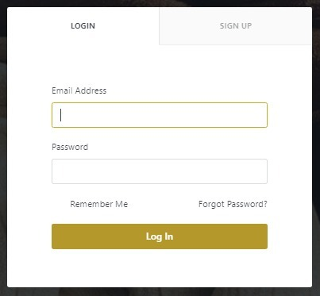

**Guidelines:**

* Does the Edited data successfully update in the database?
* Does complete data is visible.
* Does the data validated before committed to the database?
* Does the database data limits are synchronized with the front-end application?
* Does its shows error on invalid data?
* Do the user have been authorized to read insert update delete the data.
* Does image need to be cropped.
* Does image displayed after selecting image from the disk.
* Does controls enable or disable after selecting a particular case.
* Does it provide feedback after validation fail?
* Does it return the data filled form after the validation fail?
* Does it provide feedback on successful transaction?
* Does it show progress bar while posting the data to the server.
* Does it change the data in other drop-down list that is depended on the selection of current drop-down list?
* Does it support printing the data?
* Does the print’s view is adjustable for different paper sizes?
* Does it generate the pdf report for the data?

# Usability Conditions:

**Purpose:**

A usability conditions helps to ensure that the users meet their desired goals effectively and efficiently, Usability conditions determine if the interface is easy to use or not also if the system is error tolerant or not.

**Testcases:**

* Input Based (not found):
* Step Based:

1. Does the button clicked performs the required function.

**Yes, the buttons are completely functional. Here are a few of buttons in the interface.**



**Guidelines:**

* Does the buttons and key are of user-friendly size.
* Do zoom in and out facilities work as expected.
* Does the button that have same function are of same color.
* Does the buttons are placed in the same section of the screen to avoid confusion to the end users.

# Feedback:

**Purpose:**

Process in which the effect or output of an action is returned to modify the next action is known as Feedback.

**Testcases:**

* Input Based (not found):
* Step Based (not found):

**Guidelines:**

* Does the feedback I am providing specific and timely?
* Do focused on facts, not character traits?
* Do their underlying reasons for their behavior?
* Does thought about the specifics around the situation?

# Data Integration Testing:

**Purpose:**

The purpose of data integrity is to detect and assure that the data is secure and consistent. It can also be defined as the application integrity, to ensure that the performance is according to the standards if it is taken in context to the mobile applications. The data needs to be secure and consistent for the concern of performance, quality and standard.

**Testcases:**

* Input Based (not found):
* Step Based:

1. Does the sensitive information been backed up, cleaned and removed from the website?

Customer and Guest:

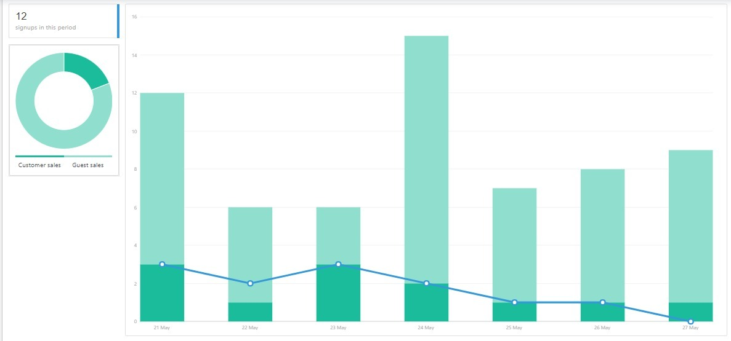

Registered Customers:

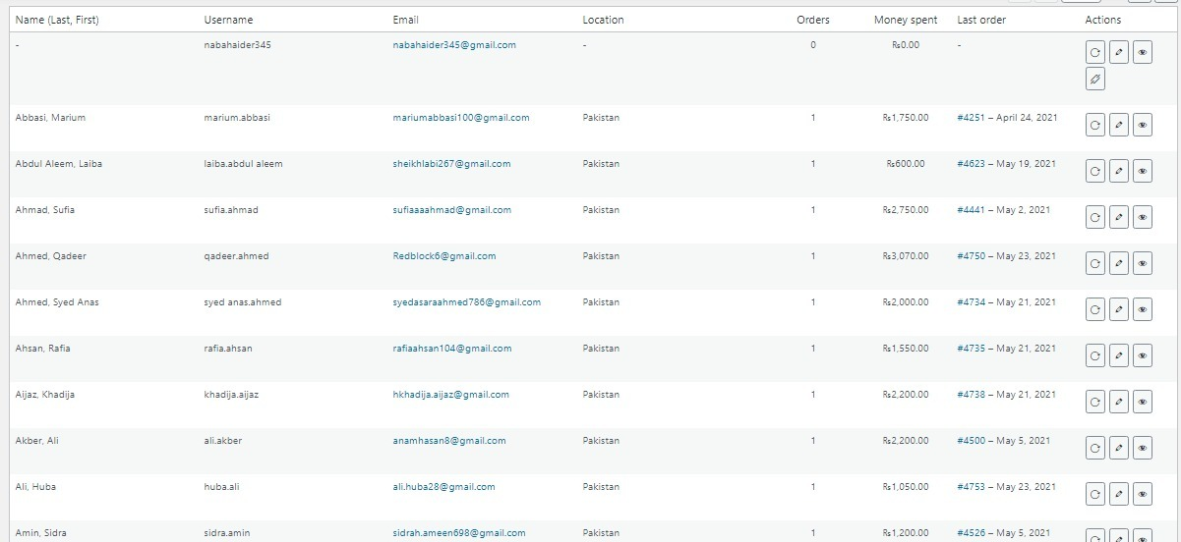

Stock updates:

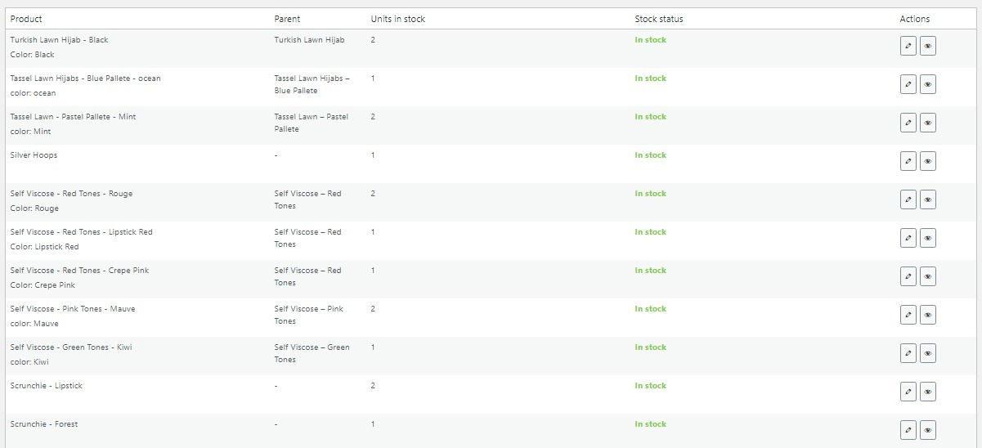

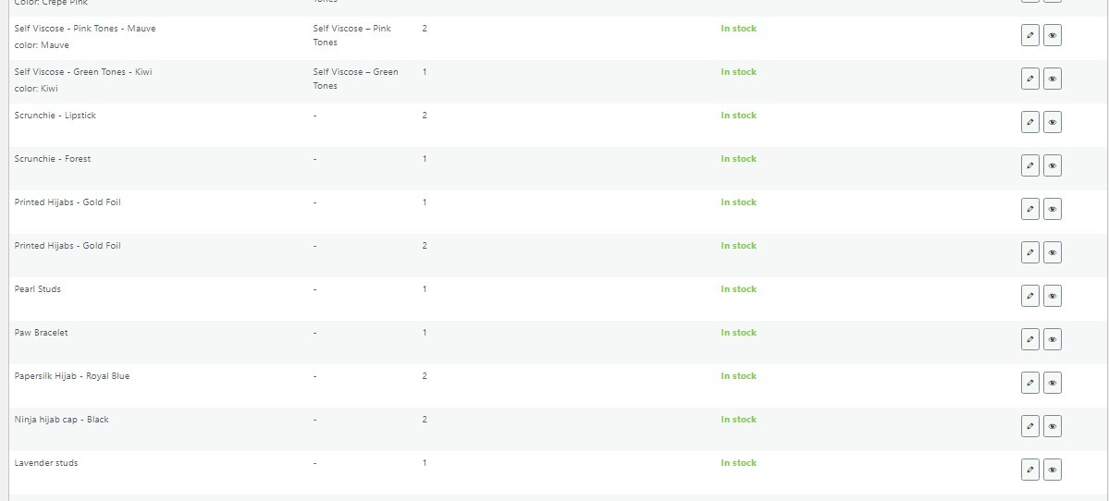

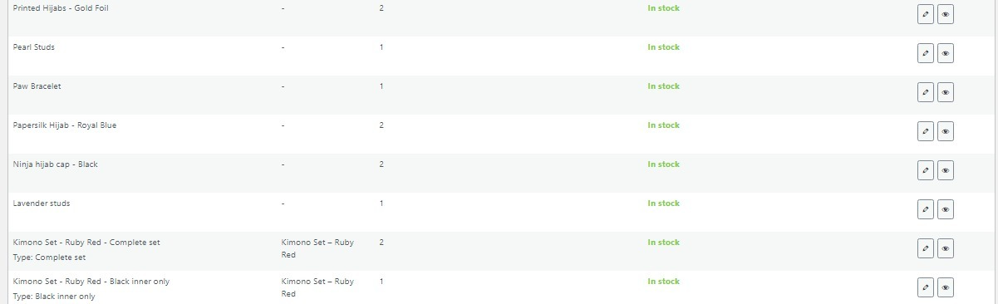

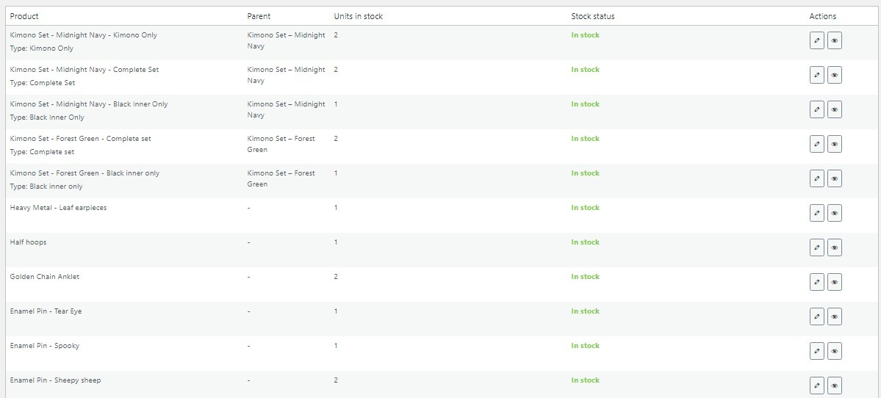

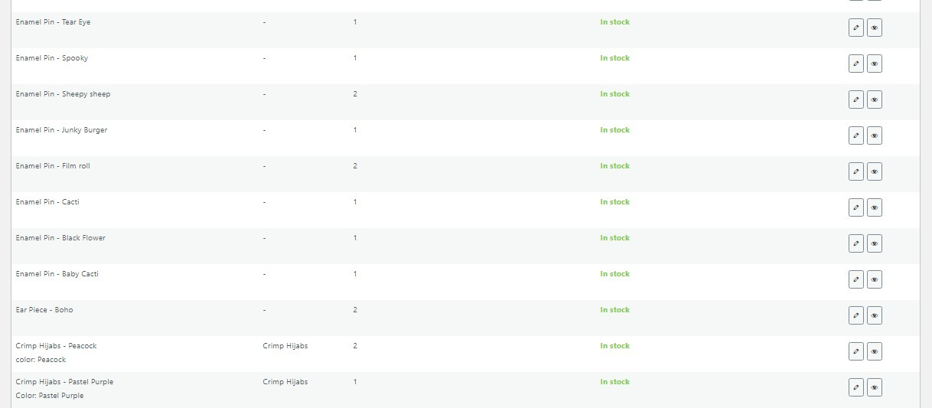

**Guidelines:**

* Does the additional security software need or available?
* Does the internet access is necessary?
* Does the sensitive information is backed up?

# Modes (Editable Read-Only):

**Purpose:**

The aim of modes is to enforce rights, authorization, and functionality integrity.

**Testcases:**

* Input Based (not found)
* Step Based:

1. Does the click made it read only?

Result: Application does not support editable read only mode on the front end interface that has been chosen.

**Guidelines:**

* Does Data to be shown in read-only mode is defined?
* Define what screens are to be shown as read-only to which users?

# General Condition:

**Purpose:**

A set of guidelines that are used to define and test many general features of the web interfaces like the navigation of the controls and performances of the apps under various conditions such as when plug in for charging does it affect the running apps or not, rights and limitations of authority of the owner and the general procedures governing the performance of the work being done by the OS or the apps running.

**Testcases:**

* Input Based (not found)
* Step Based:

1. Does the app limit or clean the amount of cached data?
   * **Yes, it does**

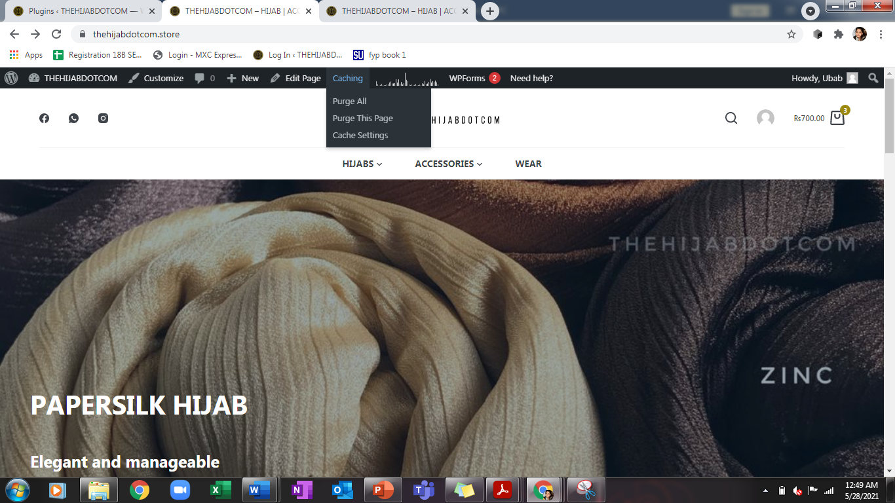

1. Does the app function as expected after refresh?
   * **Yes it does**



1. Does the app resume it is working when it gets back into network reach from outside reach of the network?
   * **A refresh hit must be provided to connect back to the website**

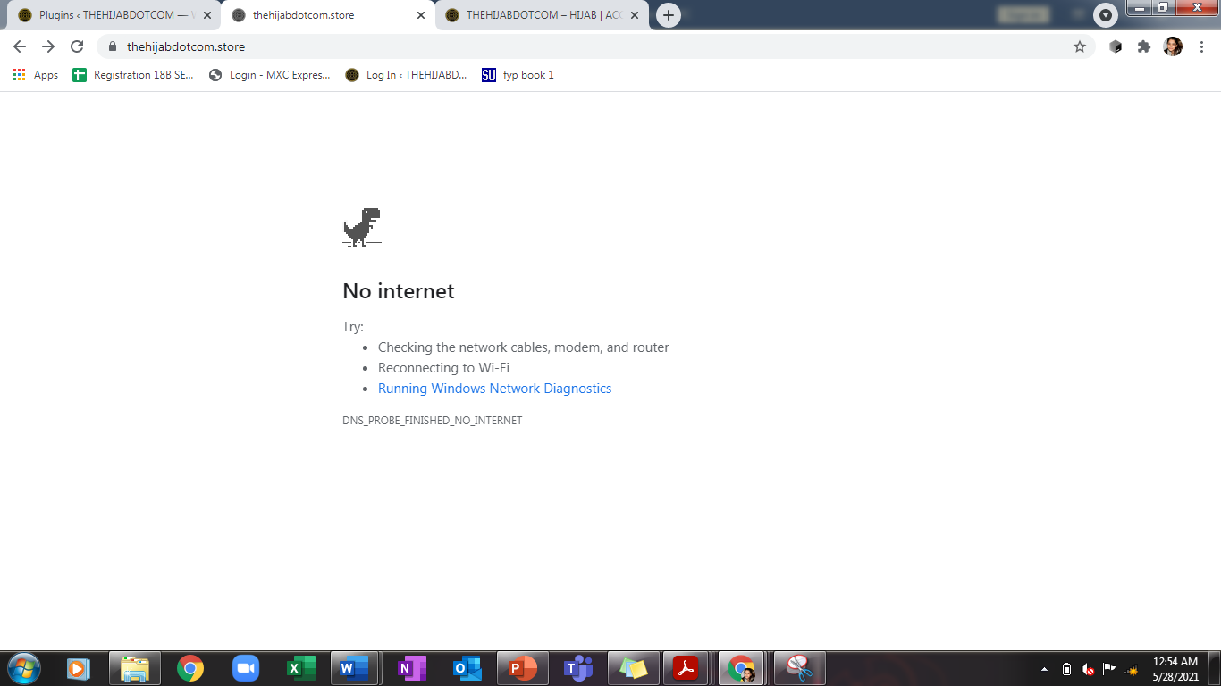

**Guidelines:**

* Does the app have been tested on different browsers?
* Does the name of App show that it is self-explanatory?
* Does it have the most common gestures used to control the app?

# Context (Not Found):

# Internal Interface (The interface chosen is an external interface):

# Connection Speed:

**Purpose:**

The purpose of connection speed is to check the maximum no of users accessing a website and how load is balanced among them and the no of users is not affecting the connection speed of the web application. In connection speed we also determine the behaviors of web app under peak and normal load

**Testcases:**

* **Input Based (Not Found):**
* **Step Based:**

1. Does many users use it at same time if yes than how many?
   * **The hosting plan is currently efficient to accommodate an audience of 2500 at once as per the payment plan and offered specifications**
2. Does it check Website application response times at different connection speeds?
   * **Yes it does, the response time of website is improved eventually by service provider to make it fast and efficient**
3. Do load your web application to determine its behavior under normal and peak loads?
   * **It may show a “Cannot Connect to data base” if the path has been disturbed to server**

**Guidelines:**

* Does it tests over various networks?
* Does it manage no of users per time?
* Does it checks for peak loads?
* Does this support fault tolerance when error occurs?
* Does it gives response times of the users?

# Browser Setting & Compatibility:

**Purpose:**

It is becoming increasingly popular for attackers to compromise computers through vulnerable web browsers. An insecure web browser can lead to spyware being installed on your computer without your knowledge, attackers taking control of your computer, stealing your information, or even using your computer to attack other computers.

**Testcases:**

* **Input Based:**

1. Does browser allow to add account to Sync data?

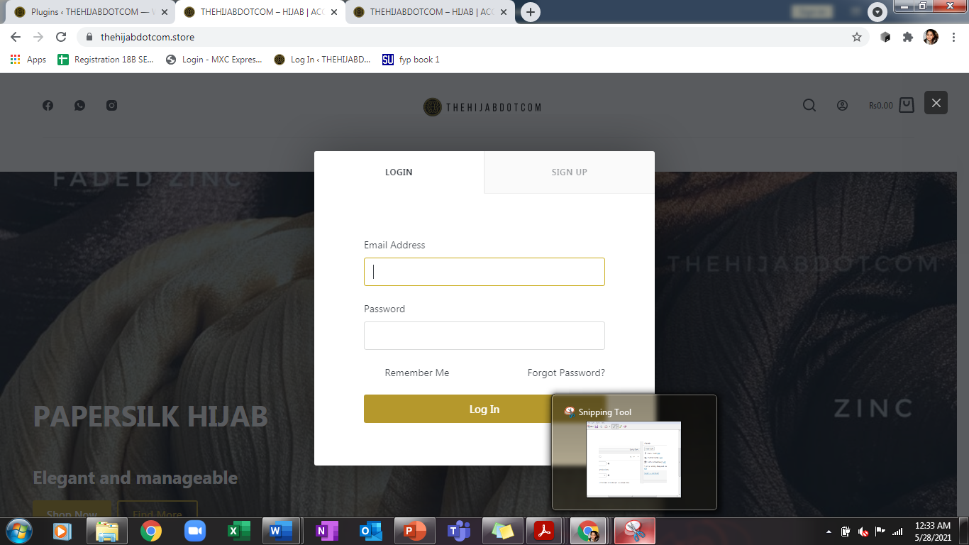

1. Does name and picture can be added?
   * Yes it can be added from edit profile option

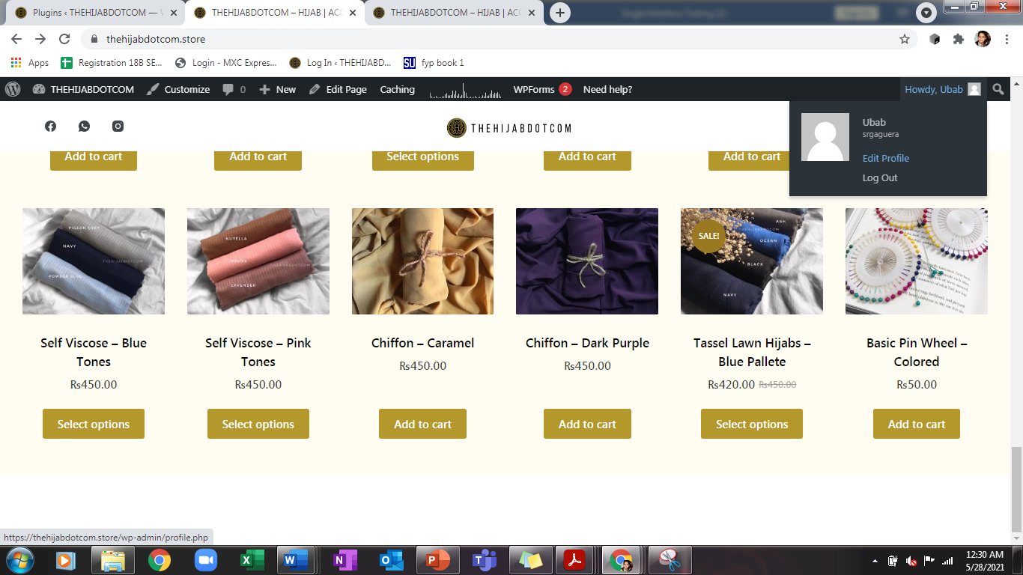

* **Step Based:**

1. Do the passwords fill auto?

**Signup option doesn’t allow a new user to set password. Password it automatically regenerated and an email for account activation is also sent**

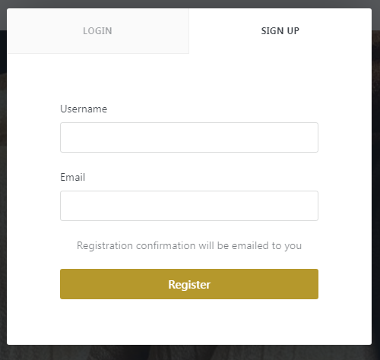

1. Does the payment method fill auto?
   * **Payment method is default to cash on delivery**
   * 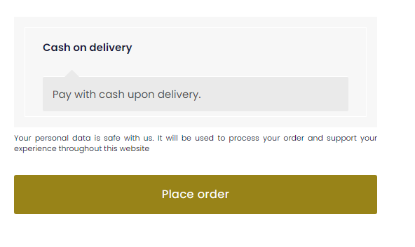
2. Does the address fill auto?
   * **If the account has been logged in and an order atleast has been placed from this account, Address details are automatically associated with the address**
   * 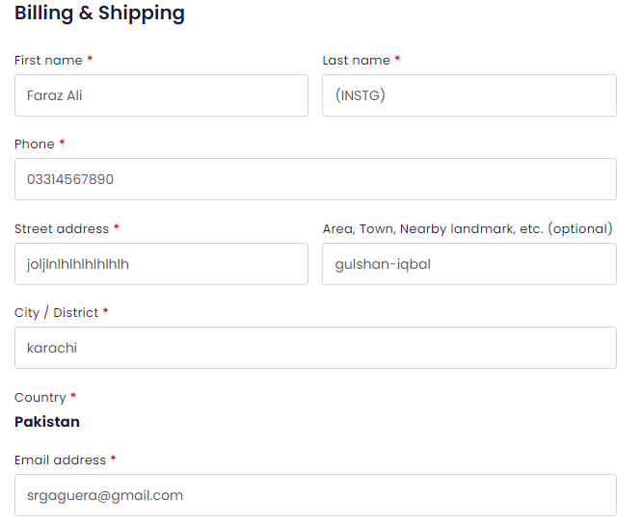
3. Does it block cookies?
   * **No cookies are not blocked**

**Guidelines:**

* Does it easy for user to access browser settings?
* Does it provide menu bar?
* Does it provide search bar?
* Does it provide subcategories?

# E-Commerce (Not Found):

# Cookies:

**Purpose:**

Cookies make the interaction between users and websites faster and easier. The purpose of the cookies is to help the website keep track of your visits and activity. Many online retailers use cookies to keep track of the items in a user’s shopping cart as they explore the site. Without cookies, your shopping cart would reset to zero every time you clicked a new link on the site. Furthermore, would be very difficult for a website to allow a visitor to fill up a shopping cart or to remember the user's preferences or registration details for a future visit. That would make it difficult to buy anything online.

**Testcases:**

* **Input Based (Not Found):**
* **Step Based:**

1. Does information stored in cookies been verified?
   * **It is being verified via a plugin additionally installed named as cookie optimizer**
2. Does the cookie information encrypt?
   * **Yes it has been verified to encrypt efficiently**
3. Do you prevented cookies from being editable by the user?
   * **User has no access to modify cookies**
4. Do cookies store in proper directory?
   * **They store in data related to the plugin “cookie optimizer”**

**Guidelines:**

* Do you have enough information about the use of cookies on websites?
* Does the website need to use persistent cookies?
* Does the website you are access is trusted enough to enable cookies?
* Do the cookies being stored successfully for verified sites?
* Do you clear cookies for websites that you have finish your transaction with?
* Do the cookies write by one website is accessible by another website?
* Do the cookies being written on multiple browsers?
* Does the website response accordingly when cookies are deleted?

# Security:

**Purpose:**

Application security is the process of developing, adding, and testing security features within applications to prevent security vulnerabilities against threats such as unauthorized access and modification. Security is the protection of information systems from theft or damage to the hardware, the software, and to the information on them, as well as from disruption or misdirection of the services they provide.

**Testcases:**

* **Input Based:**

1. Does your server lock out an individual who has tried to access your site multiple times with invalid login/password information?
   * **The website requests them to reset their password via email if they forgot the previous one**
2. Do verify the timeout condition, after timeout user should not able to navigate through the site?
   * **The timeout condition is set as 8 hours, after 8 hours the website requests you to login again**
3. Do Verify that system should restrict you to download the file without sign in on the system?
   * **A file can only be downloaded if the product is set as a downloadable product and only after the user has logged in**
4. Do check the valid and invalid passwords, password rules say cannot be less than 6 characters, user id and password cannot be the same etc.?

**PASSWORD CONDITIONS:**

* + **Password cannot be same as username**
  + **Password cannot be less than 8 characters in length**
  + **Password must include a numeric value, an uppercase and a lower case**
* **Step Based (Not Found):**

**Guidelines:**

* Do keep personal information professional and limited?
* Does it keep your privacy settings on?
* Do practice safe browsing?
* Is your internet connection secure?
* Do be careful what you download?
* Did you choose strong passwords?
* Do be careful what you post?
* Do be careful who you meet online?
* Do keep your antivirus program up to date?